**实验四：工厂模式**

1、简单工厂模式

项目目录：

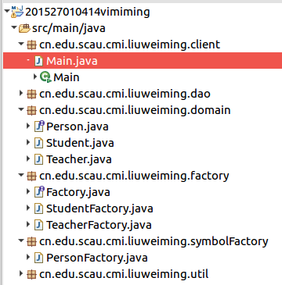

1.1、用一个工厂来创造所有对象(simple factory)：

|  |  |
| --- | --- |
| 1  2  3  4  5  6  7  8  9 10  11  12  13  14  15  16  17  18  19 20  21  22  23  24  25  26  27  28  29 30  31  32  33  34  35  36  37  38  39 40  41  42  43  44  45  46  47  48  49 50  51  52  53  54  55  56  57  58  59 60  61  62  63  64  65  66  67  68  69 70  71  72  73  74  75  76  77  78  79 80  81  82  83  84  85  86  87  88  89 90  91  92  93  94  95  96  97  98  99100  101  102  103  104 | package cn.edu.scau.cmi.liuweiming.domain;  **public** **interface** Person {  String getName();}  *// Student*package cn.edu.scau.cmi.liuweiming.domain;  **public** **class** Student **implements** Person {  **private** String studentID, studentName;  **public** String getStudentID() {  **return** studentID;  }  **public** **void** setStudentID(String studentID) {  **this**.studentID = studentID;  }  **public** String getStudentName() {  **return** studentName;  }  **public** **void** setStudentName(String studentName) {  **this**.studentName = studentName;  }    **public** Student() {  studentID = **null**;  studentName = **null**;  }  **public** Student(String studentID, String studentName) {  **super**();  **this**.studentID = studentID;  **this**.studentName = studentName;  }    **public** String getName() {  **return** **this**.studentName;  }}  *// Teacher*  package cn.edu.scau.cmi.liuweiming.domain;  **public** **class** Teacher **implements** Person {  String id, name;  **public** String getId() {  **return** id;  }  **public** **void** setId(String id) {  **this**.id = id;  }  **public** String getName() {  **return** name;  }  **public** **void** setName(String name) {  **this**.name = name;  }  **public** Teacher(String id, String name) {  **super**();  **this**.id = id;  **this**.name = name;  }  **public** Teacher() {  **super**();  }  }  *//Simple factory*  package cn.edu.scau.cmi.liuweiming.symbolFactory;  import **cn.edu.scau.cmi.liuweiming.domain.Person**;  import **cn.edu.scau.cmi.liuweiming.domain.Student**;  import **cn.edu.scau.cmi.liuweiming.domain.Teacher**;  **public** **class** PersonFactory {  **final** **static** String student = "student";  **final** **static** String teacher = "teacher";  **public** **static** Person getPerson(String name) {  **if** (name.equals(student)) {  **return** **new** Student();  } **else** **if** (name.equals(teacher)) {  **return** **new** Teacher();  } **else** {  System.out.println("no this element");  **while** (**true**);  }  }  } |

1.2、一个工厂创建一种对象

|  |  |
| --- | --- |
| 1  2  3  4  5  6  7  8  9 10  11  12  13  14  15  16  17  18  19 20  21  22  23  24  25  26  27  28  29 30  31  32  33  34  35  36  37  38  39 40  41  42  43  44  45  46  47  48  49 50  51  52  53  54  55  56  57  58  59 60  61  62  63  64  65  66  67  68  69 70  71  72  73  74  75  76  77  78  79 80  81  82  83  84  85  86  87  88  89 90  91  92  93  94  95  96  97  98  99100  101  102  103  104  105  106  107  108  109110  111 | package cn.edu.scau.cmi.liuweiming.domain;  **public** **interface** Person {  String getName();  }  *// Student*  package cn.edu.scau.cmi.liuweiming.domain;  **public** **class** Student **implements** Person {  **private** String studentID, studentName;  **public** String getStudentID() {  **return** studentID;  }  **public** **void** setStudentID(String studentID) {  **this**.studentID = studentID;  }  **public** String getStudentName() {  **return** studentName;  }  **public** **void** setStudentName(String studentName) {  **this**.studentName = studentName;  }    **public** Student() {  studentID = **null**;  studentName = **null**;  }  **public** Student(String studentID, String studentName) {  **super**();  **this**.studentID = studentID;  **this**.studentName = studentName;  }    **public** String getName() {  **return** **this**.studentName;  }}  *// Teacher*  package cn.edu.scau.cmi.liuweiming.domain;  **public** **class** Teacher **implements** Person {  String id, name;  **public** String getId() {  **return** id;  }  **public** **void** setId(String id) {  **this**.id = id;  }  **public** String getName() {  **return** name;  }  **public** **void** setName(String name) {  **this**.name = name;  }  **public** Teacher(String id, String name) {  **super**();  **this**.id = id;  **this**.name = name;  }  **public** Teacher() {  **super**();  }  }  *//factory*  package cn.edu.scau.cmi.liuweiming.factory;  **public** **interface** Factory {  }  *//StudentFactory*  package cn.edu.scau.cmi.liuweiming.factory;  import **cn.edu.scau.cmi.liuweiming.domain.Student**;  **public** **class** StudentFactory **implements** Factory {  **public** **static** Student getStudent() {  **return** **new** Student();  }  }  *//TeacherFactory*  package cn.edu.scau.cmi.liuweiming.factory;  import **cn.edu.scau.cmi.liuweiming.domain.Teacher**;  **public** **class** TeacherFactory **implements** Factory {  **public** **static** Teacher getStudent() {  **return** **new** Teacher();  }  } |

2、抽象工厂模式

项目目录

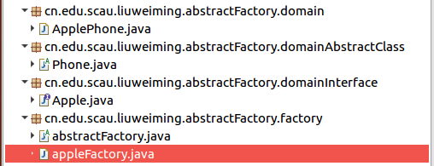

|  |  |
| --- | --- |
| 1  2  3  4  5  6  7  8  910  11  12  13  14  15  16  17  18  1920  21  22  23  24  25  26  27  28  2930  31  32  33  34  35  36 | package cn.edu.scau.liuweiming.abstractFactory.domain;  import **cn.edu.scau.liuweiming.abstractFactory.domainAbstractClass.Phone**;import **cn.edu.scau.liuweiming.abstractFactory.domainInterface.Apple**;  **public** **class** ApplePhone **extends** Phone **implements** Apple {  }  package cn.edu.scau.liuweiming.abstractFactory.domainAbstractClass;  **public** **abstract** **class** Phone {  }  package cn.edu.scau.liuweiming.abstractFactory.domainInterface;  **public** **interface** Apple {  }  package cn.edu.scau.liuweiming.abstractFactory.factory;  **public** **abstract** **class** abstractFactory {  }  package cn.edu.scau.liuweiming.abstractFactory.factory;  **public** **class** appleFactory **extends** abstractFactory {  } |